Documentation TourUG

Course Instructor: Kalumba Hillary

Student name: Candia James

Reg. No: Sept18|Bist|oo4u

Course Code: NW 303

Course Name: MObile Applications Programming

I State and explain the idea or problem they are trying to solve

The application will help in enabling the vistors or tourists in availing booking information and tour sites within uganda

II How they developed the application including tools and technologies

The applications developed using Java Programming Language and the tool used is Android Studio.

III Why they developed it that way

It was developed in that Android platform because it has the neccessary tools and acomodate almost all the Smart phones in the market

IV How they think the application will solve the problem.

It will solve because if you look at some Tour Mobile Applications they seem to lack the technology to be used and even some have to use manual ways of giving informations to their clients and posssibly taking physically to the sites yet the mobile would be idea platform to sell their information to their clients.

Screenshots

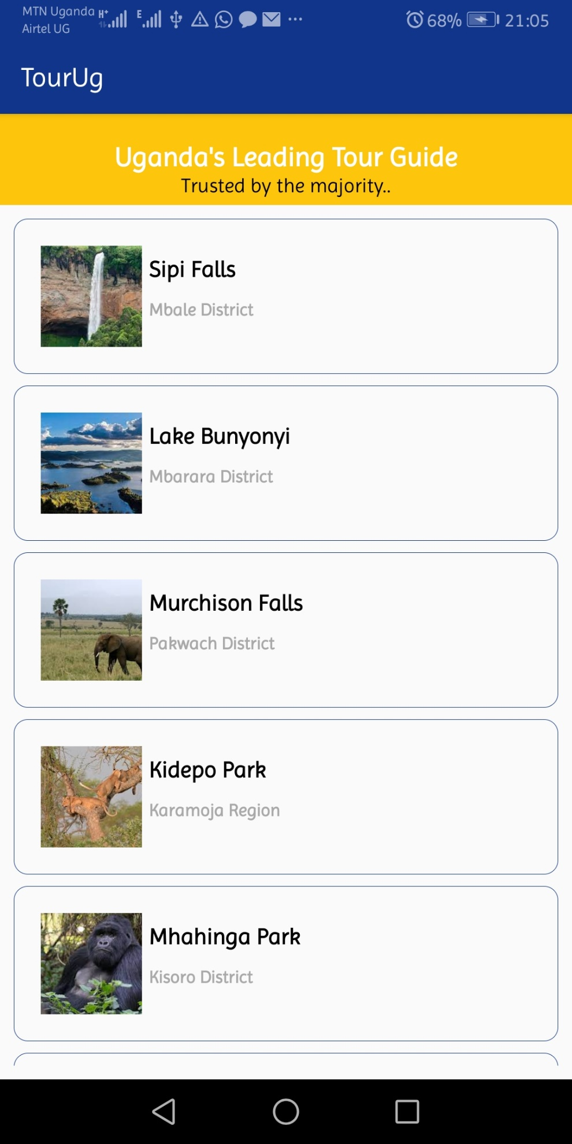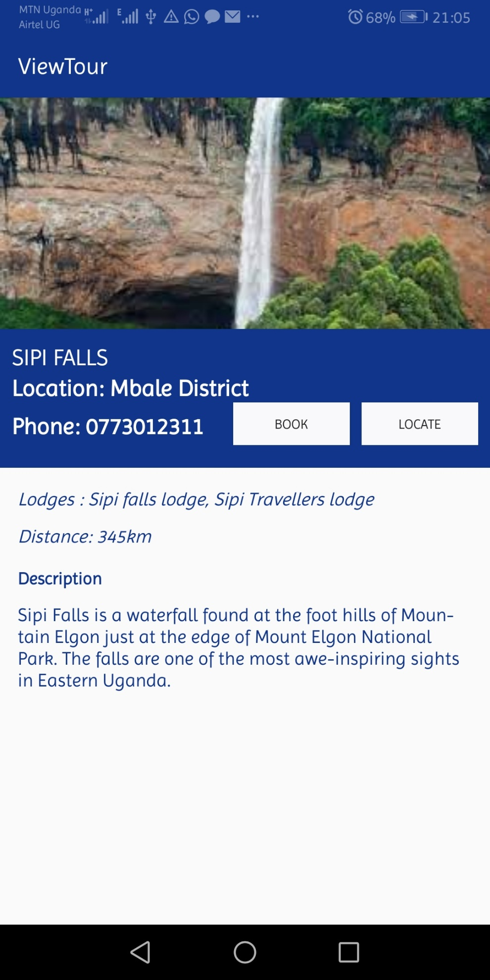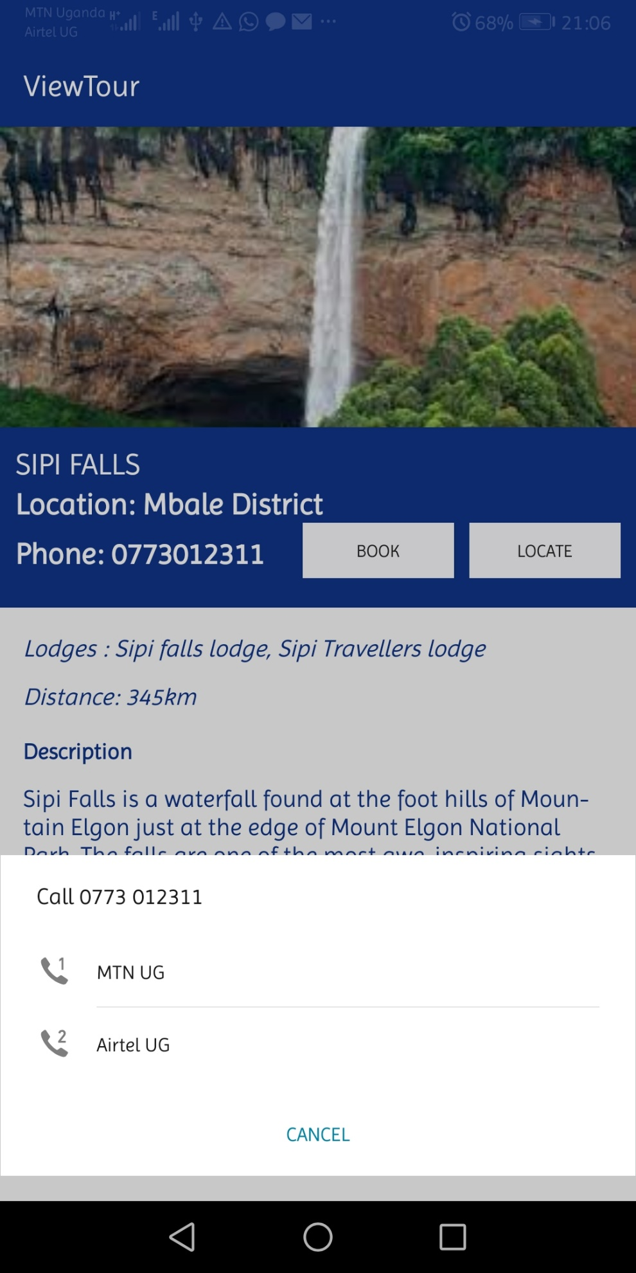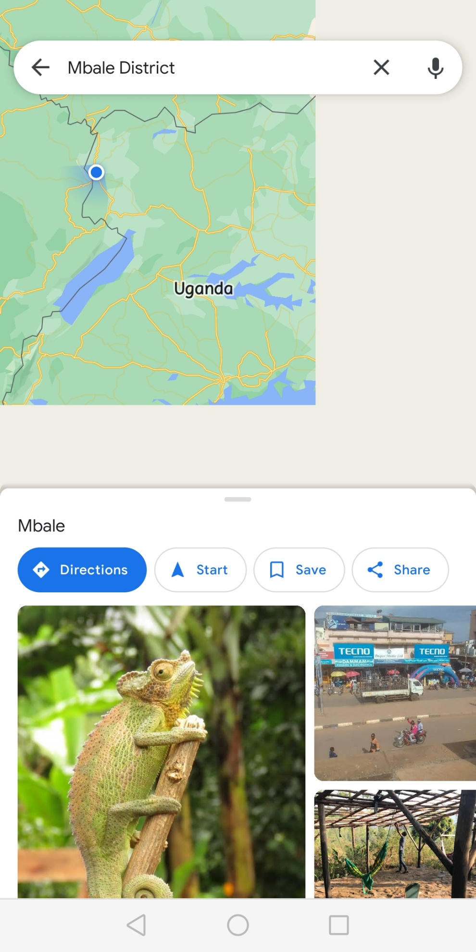

URL: [VitaJa/TourUg (github.com)](https://github.com/VitaJa/TourUg)